1. **Social circles: Facebook**

This dataset consists of 'circles' (or 'friend’s lists') from Facebook. Facebook data was collected from survey participants using this [Facebook app](https://www.facebook.com/apps/application.php?id=201704403232744). The dataset includes node features (profiles), circles, and ego networks.

This database contains the following information

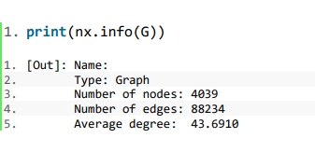

1. **Degree Centrality**

Degree centrality is a simple count of the total number of connections linked to a vertex. It can be thought of as a kind of popularity measure, but a crude one that does not recognize a difference between quantity and quality.

Equation presents how degree centrality is calculated. Although it might seem a simple task to just add up the number of connections of each node, that is essentially what this equation is doing!

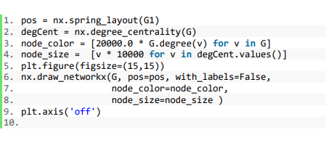

1. **Betweenness Centrality**

Betweenness centrality is a measure of centrality in a graph based on shortest paths.

To **calculate Betweenness centrality**, you take every pair of the **network** and count how many times a node can interrupt the shortest paths (geodesic distance) between the two nodes of the pair.

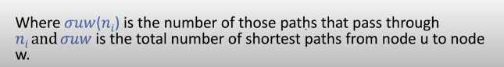

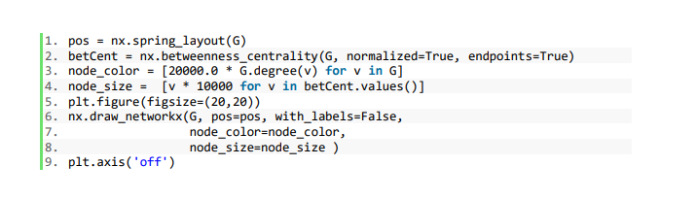

1. **Closeness Centrality**

**Closeness centrality** is a measure of the average shortest **distance** from each vertex to each other vertex. Specifically, it is the inverse of the average shortest **distance** between the vertex and all other vertices in the **network**.

The **formula** is

1. / (average **distance** to all other vertices)

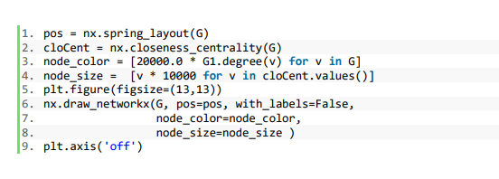

1. **Eigenvector Centrality**

**Eigenvector centrality** is a **centrality** index that calculates the **centrality** of an actor based not only on their connections, but also based on the **centrality** of that actor's connections.

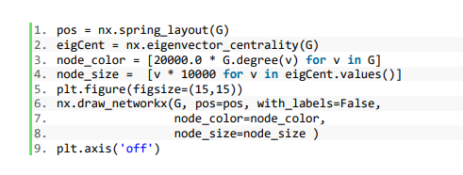

1. **Find the shortest path between nodes along with their length**

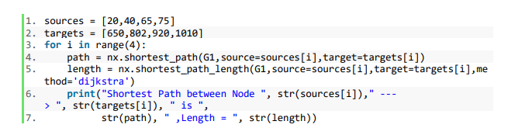

1. **Find the shortest path between nodes along with their length**

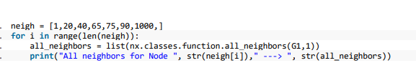

1. Find the degrees of the nodes along with the number of degrees in the graph

